|  |  |
| --- | --- |
| valuable insights  **Unified Properties Company** | **Abstract**  **Using dashboard as a powerful analytical tool to consolidate crucial information from different aspects of real estate into a central, visual interface. It allows the property-owners, investors, and real estate professionals to examine, monitor, and draw actionable conclusions from key performance indicators (KPIs) pertinent to market trends and properties characteristics.**  **Ezeh C.L**  **Data Science** |

# **Introduction (Project Information)**

**Name of student:**

**Ezeh Chukwunonso Lawrence**

**Name of School:**

**Xaltiux Academy**

**Course:**

**Data Science**

**Project Company**

**Property Owners, Investors, and Real Estate Professionals**

# **Title.**

**TO develop an intuitive and comprehensive dashboard for Property owners, investors, and real estate professionals TO rely on for accurate and reliable valuation estimates to determine fair market prices, negotiate deals, and assess investment opportunities In the real estate industry AND TO MAKE informed buying and selling decisions.**

**Prepared for Mrs. SHIVANGI, tutor,**

**xalTius academy.**

**by**

**ezeh chukwunonso lawrence**

**date**

**march 31st, 2025**

# **Table of Content**

**Introduction (Project Information)** i

**Title.** ii

**Table of Content** iii

**Figures** iv

**Chapter 1.** **Introduction** 1

**1.1. Problem Statement** 1

**1.2. Objective Research** 1

**1.3. Data Understanding and Preparation** 1

**Chapter 2. Key findings/Insights** 2

**2.1. Overall Findings** 2

**2.2. Average Resale Price by Year** 2

**2.3. Total Resale Price by Year** 2

**2.4. Total Flat Type by Town** 3

**2.4. Total Resale Price by Town** 3

**2.4. Average Resale Price by Town** 4

**2.5. Total Resale Price by Flat Type** 4

**2.6. Total Flat Types** 5

**2.7. Total Remaining Lease by Year** 6

**2.8. Total Remaining Lease by Flat-Type** 6

**Chapter 3. Recommendations and Conclusion** 7

**Recommendation Based on Data Analysis** 7

# **Figures**

***[Figure 1: Total Resale Price……………………………………………………. …………………………….2 Figure 2: Total Months…………………………………………………………………………………………2 Figure 3: Total Blocks](#_Toc193723081)*** [2](#_Toc193723081)

***Figure 4: Average Resale Price by Year*** 2

***Figure 5: Total Resale Price by Year*** 3

***Figure 6: Total Flat-Type by Town*** 3

***Figure 7: Total Resale Price by Town*** 3

***Figure 8: Average Resale Price by Town*** 4

***Figure 9: Total Resale Price by Flat-Type*** 4

***Figure 10: Average Resale Price by Flat-Type*** 5

***Figure 11: Total Flat-Types*** 5

***Figure 12: Total Remaining Lease by Year*** 6

***Figure 13: Total Remaining Lease by Flat-Type*** 6

# 

# **Chapter 1. Introduction**

This chapter defines the problem situation, and the research objective

# **1.1. Problem Statement**

To develop an intuitive and comprehensive dashboard for property owners, investors, and real estate professionals to rely on for accurate and reliable valuation estimates to determine fair market prices, negotiate deals, and assess investment opportunities in the real estate industry and to make informed buying and selling decisions.

# **1.2. Objective Research**

The task is to generate a report with some important insights which can be helpful for the property owners, investors, and real estate professionals to better understand their customers and the real estate industry. by exploring the dataset of the company and come up with the solutions. The data provided contains all the required detail such as flat model, property characteristics, towns, and resales price.

**1.3. Data Understanding and Preparation**

First step towards the analysis is to understand and prepare the data I have, once I get the idea about the features given in the dataset and the relationship among the variables then I can start preparing the dataset for the data analysis.

Data preparation is important because I need to transform the data as per the requirements like imputing missing values, changing the data type, deriving a custom column etc.

# **Chapter 2. Key findings/Insights**

This chapter highlights major findings during analyses and visualizations from the data provided. After visualizing and analysing the data provided, major finding and insights were derived from the dataset. The following findings are as follow:

# **2.1. Overall Findings**

## The overall findings/insights made during analysis and visualization are the total resale price, the total number of months, and total number of blocks. The company made over 63 billion dollars in resale for period of 88 months (7 years and 4 months) from over 141k blocks.

***Figure 1: Total Resale Price Figure 2: Total*** ***Months*** ***Figure 3: Total Blocks***

# **2.2. Average Resale Price by Year**

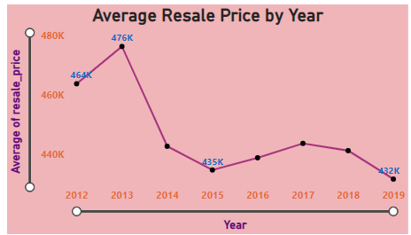In the figure below, it displayed the average resale for each year. It also displayed the years with the highest average resale price (2013, followed by 2012, and 2017) and also the years with low average resale price (2019, followed by 2015 and 2016)

# ***Figure 4: Average Resale Price by Year***

# **2.3. Total Resale Price by Year**

# Just like 2013, followed by 2012, and 2017 top the chart for the average resale price by year and the year 2019, followed by 2015 and 2016 make-ups the years with low average resale price. This is totally different for the years with the highest total resale prices. 2018 and 2012 top the list for the highest total resale price while 2019 and 2015 make-ups the list for the years with low total resale price.

# ***Figure 5: Total Resale Price by Year***

# **2.4. Total Flat Type by Town**

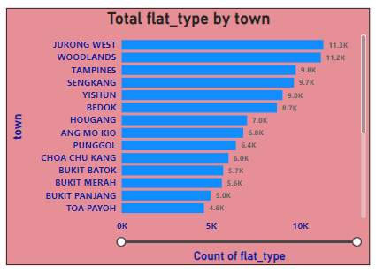The figure below displayed the total number of flat types for each town with Jurong West and Woodlands toping the chart with over 11k flat type, followed by Tampines, Sengkang, and Yish uwith over 9k flat types each.

# ***Figure 6: Total Flat-Type by Town***

# **2.4. Total Resale Price by Town**

The figure below displayed the towns with the highest and lowest number of resale price. For the towns with high total resale price, Jurong West topping the chart with over 4.6 billion, followed by Tampines and Woodlands with over 4.5 billion in resale price each, while towns like Bukit Timah, Marine Paraade, and Central Area make-up the list of towns with low resale prices of 240 millions, 511 millions, and 707 millions respectively.

# 

# ***Figure 7: Total Resale Price by Town***

# **2.4. Average Resale Price by Town**

In the figure below, Bukit Timah (695,867) and Central Area (601,055) are the most expensive while Yishun (371,329) and Woodlands (404,474) are the most affordable.

# ***Figure 8: Average Resale Price by Town***

# **2.5. Total Resale Price by Flat Type**

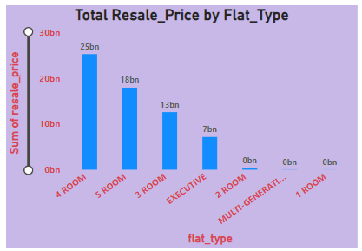The figure below displayed the flat types with the highest and lowest number of resale price. For the flat types with high resale price, 4 room flat type top the chart with over 25 billion, followed by 5 rooms and 3 rooms with 18 billion and 13 billion respectively.

# ***Figure 9: Total Resale Price by Flat-Type***

**2.6. Average Resale Price by Flat Type**

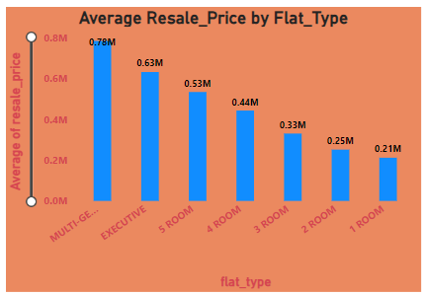Multi-Generation flats have the highest average price (784,378), followed by Executive flats (631,846). 1-room flats are the most affordable (211,686). Followed by 2 room flats (251349)

# ***Figure 10: Average Resale Price by Flat-Type***

# **2.6. Total Flat Types**

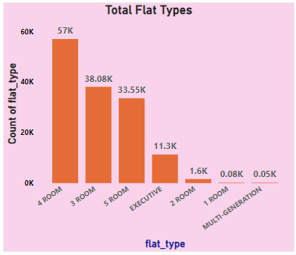The figure below displayed the flat types with the highest and lowest numbers. For the flat types with high numbers, 4 room flat type top the chart with over 57 thousand flat types, followed by 3 rooms and 5 rooms with 38.08 and 33.55 thousand flat types respectively

# ***Figure 11: Total Flat-Types***

# 

# **2.7. Total Remaining Lease by Year**

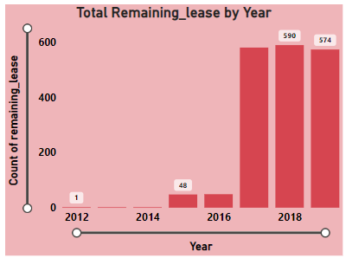For the remaining lease by year, Unified Properties did not perform well as regards to the number of remaining leases for the following year: 2017 with 518 remaining leases, followed by 2019 and 2018 with 574 and 590 remaining leases respectively.

# ***Figure 12: Total Remaining Lease by Year***

# **2.8. Total Remaining Lease by Flat-Type**

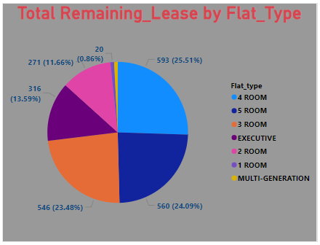For the remaining lease by year, Unified Properties did not perform well as regards to the number of remaining leases for the following flat types: 4 rooms with 593 remaining leases, followed by 5 rooms and 3 rooms with 560 and 546 remaining leases respectively

# ***Figure 13:*** ***Total Remaining Lease by Flat-Type***

# **Chapter 3. Recommendations and Conclusion**

**Recommendation Based on Data Analysis**

**1. Resale Price by Year**

* The highest average resale price was in 2013 (476,441 USD).
* Prices declined from 2014 to 2019, with 2019 having the lowest (431,632 USD).
* The decline suggests market corrections, government policies, or changes in demand.

**Recommendation:**

* If purchasing, 2019 offers better affordability.
* If selling, consider market recovery trends before listing.

**2. Resale Price by Flat Type**

* Multi-Generation flats have the highest average price (784,378 USD).
* 1-room flats are the most affordable (211,686 USD).
* Price increases with size, with Executive flats at 631,846 USD.

**Recommendation:**

* Larger flats (Executive & Multi-Generation) are more valuable, ideal for families.
* Smaller flats (2-room & 3-room) are cost-effective for individuals or small households.

**3. Resale Price by Town**

* Bukit Timah (695,867 USD) and Central Area (601,055 USD) are the most expensive.
* Yishun (371,329 USD) and Woodlands (404,474 USD) are the most affordable.

**Recommendation:**

* Buyers should consider Bukit Timah & Central Area for long-term appreciation.
* Affordable housing seekers can explore Yishun, Woodlands, and Bukit Batok.